The Constitution
British Prime Minister, William E. Gladstone, once declared that the United States Constitution was “the most wonderful work ever struck off at a given time by the brain of man.” Gladstone used these words to describe the Constitution a century after the former British colonies had won the Revolution and become a new, independent nation.

Section I: Structure and Principles
The Founders created the Constitution more than 200 years ago. It established a republic in which power is held by voting citizens through their elected representatives. The Constitution of the United States provides citizens with information about their ____________________ and what they can reasonably expect of their ____________________. Our constitution is considered to be _________________________________________ compared to other countries. The US Constitution contains about ________________________ and is divided into ____________________________: ______________________________, _______________________________, and _______________________________.
The Preamble
"We the People of the United States, in Order to form a more perfect Union, establish Justice, insure domestic Tranquility, provide for the common defense, promote the general Welfare, and secure the Blessings of Liberty to ourselves and our Posterity, do ordain and establish this Constitution for the United States of America."
- Serves as an introduction
- States why the Constitution was written
- The Founders indicated in the Preamble that they wanted a government that would
  - ________________________________________________________
  - ________________________________________________________
  - ________________________________________________________
Seven Articles
There are 7 main divisions of the body of the Constitution called ___________________________. Each article covers a _______________________________________ with most articles further divided into sections.
Article I – ____________________________________________________________________
  - Section 1 – creates ________________________________________________
  - Sections 2 and 3 – set forth details about the two houses of Congress:
    - ________________________________________________________
    - ________________________________________________________
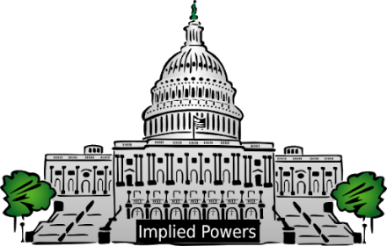
CONGRESS
The House of Representatives | Senate

Additional sections of Article I spell out procedures for _______________________________________:
- ____________________________________________________________________
- ____________________________________________________________________
- ____________________________________________________________________
The Founders gave Congress _________________________________________, or the powers directly stated in the Constitution. Most of the expressed powers are itemized in Article I, Section 8. These are called ________________________________________ because they are numbered _________________________. The final enumerated power is called _______________________________________________. This clause gives Congress the right to make all laws “ ________________________________________________” to carry out the other expressed powers. This clause allows Congress ___________________________ its powers to meet situations the Founders could not anticipate.
The first Congress introduced 167 bills, and legislating was considered a part-time job. Today, a total of 100,000 bills are introduced each year and members of Congress work nearly year-round in Washington, D.C.
Article II - _______________________________________________________
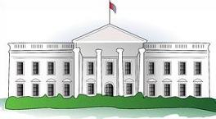
- __________________________________________________________
- __________________________________________________________
- __________________________________________________________
- ___________________________________________________________________________________________
- Section 1 establishes the office of _______________________________________________________________
- Additional sections of Article II detail _____________________________________________________________
  - _________________________________________________________________________
  - _________________________________________________________________________
  - _________________________________________________________________________
  - _________________________________________________________________________
  - _________________________________________________________________________
Article III - _________________________________________________________
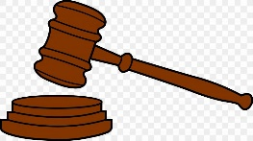
- Section 1 establishes the ________________________________________ as the
head of the judicial branch.
- _____________________________________________________________
- __________________________________________________________________________________________
- Section 2 outlines _______________________________________________
  - _______________________________________________________________________________
- Section 3 defines _______________________________________________________________
Article IV – explains the relationship of __________________________________________________________________
__________________________________________________________________________________________
- Guarantees the national government will _________________________________________________________
___________________________________________________________________________________________

- Requires ___________________________________________________________________________________
___________________________________________________________________________________________

- Addresses admitting new states
Article V - The Amending Process
- There are currently _____________________________________
- ___________________________________________________________________________________________
- ___________________________________________________________________________________________
Article VI - National Supremacy
- The Supremacy Clause - _________________________________________________________________
_____________________________________________________________________________________
_____________________________________________________________________________________
Article VII – Ratification of the Constitution
- Required approval of _________________ of the original 13 states
- _________________________ of the 55 delegates at the Constitutional Convention signed the Constitution
- Went into effect in ________________________________

The Amendments
The third part of the Constitution contains the amendments, or changes. The Constitution has been amended __________________ throughout the nation’s history. It is considered a “____________________________________.” The amendment process provides a way for the document, written over two centuries ago, to remain responsive to the needs of a changing nation.
6 Major Principles
The Constitution rests on six major principles of government:
- ___________________________________________________________
- ___________________________________________________________
- ___________________________________________________________
- ___________________________________________________________
- ___________________________________________________________
- ___________________________________________________________
Major Principles Explained
- Popular Sovereignty - ________________________________________________________________

- Federalism - _______________________________________________________________________
__________________________________________________________________________________

- Separation of Powers - _______________________________________________________________
__________________________________________________________________________________
__________________________________________________________________________________

- Checks and Balances - ________________________________________________________________
__________________________________________________________________________________
For Example: Congresses passes laws, but the POTUS can veto; however, Congress can override veto by 2/3 vote of each house. The Judicial Branch can rule the law unconstitutional. The POTUS has the power to appoint judges. Congress has to approve appointments. They also have the power to impeach.

- Judicial Review
  - ______________________________________________________________________________
  - ______________________________________________________________________________
______________________________________________________________________________
- Supreme Court Case: Marbury v. Madison - (SEE HANDOUT)

- Limited Government - __________________________________________________________________
____________________________________________________________________________________

